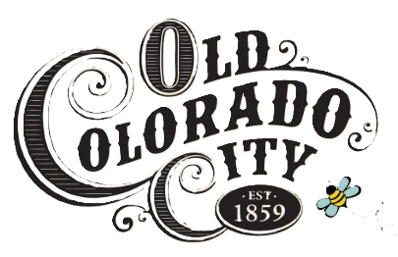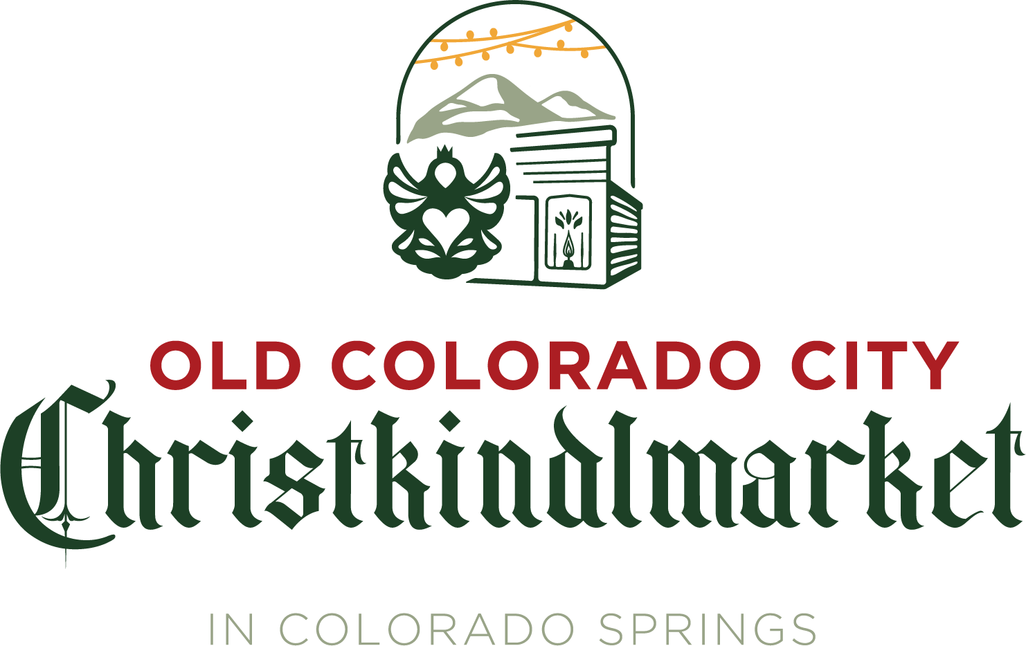

*For Immediate Release*

**FOR MORE INFORMATION**

Samantha Seems, Executive Director & Board Secretary

German American Chamber of Commerce – Colorado Chapter

(719) 822-2058

[samantha.seems@gacc-co.org](mailto:samantha.seems@gacc-co.org)

**GACC-CO Expands Its Beloved Christkindlmarket to Colorado Springs**

The German American Chamber of Commerce - Colorado Chapter (GACC-CO) is thrilled to announce the expansion of its beloved Christkindlmarket to an additional location in 2025. This new authentic, German-style holiday market will be located in Old Colorado City in Colorado Springs, CO. “The GACC-CO wanted to take the Denver Christkindlmarket’s success of strengthening the city’s culture and economic opportunities to Colorado Springs by producing a Christkindlmarket that reflects its extraordinary community and adds to the magic of the holiday season,” said Samantha Seems, GACC-CO Executive Director.

Colorado Springs has a rich and unique heritage built upon the spirit of Gold Rush pioneers, Olympic hopefuls, and dedicated military personnel and families. Old Colorado City (OCC), a thriving arts district committed to preserving Colorado Springs’s culture and history, is the ideal location for a festive and cozy Christkindlmarket. Sara Vaas, President of OCC Partnership, explains, “Old Colorado City and the German American Chamber of Commerce recognize the sights, sounds, and tastes that make Colorado Springs unique are the reason the city flourishes. The Old Colorado City Christkindlmarket will be a festive holiday market representing the culture, businesses, and people of Colorado Springs.”

With over 20% of Colorado Springs residents claiming German ancestry, the city is a natural fit for this authentic German holiday market. Barbara Wittmann, GACC-CO President, says, “Experiencing other cultures or even getting a better understanding of your own heritage opens people’s perspectives and fosters meaningful connections. The OCC Christkindlmarket is a great opportunity for people of all backgrounds to meet and connect with their neighbors to celebrate the season.”

In addition to bringing a taste of Germany to Colorado Springs, the OCC Christkindlmarket promotes small, local businesses and creates new seasonal jobs. Quality vendors, festive decorations, and free local entertainment attract holiday shoppers from around the state and possibly the nation. This seasonal boost in tourism benefits surrounding local shops, hotels, and restaurants, generating a positive financial impact for Colorado Springs.

Details on opening dates, vendors, and entertainment schedules will be announced soon. For the latest information, please visit [www.OCCchristkindlmarket.com](https://www.occchristkindlmarket.com) or contact Samantha Seems with any questions.

**Samantha Seems, Executive Director & Board Secretary**

German American Chamber of Commerce – Colorado Chapter

(719) 822-2058

[samantha.seems@gacc-co.org](mailto:samantha.seems@gacc-co.org)

###